**Exp-5 Resume Website**

**Aim:** To make a Resume website using HTML and CSS.

**Theory:** This HTML file represents a resume webpage for *Sneh Naik*, structured using basic HTML and CSS. The page follows a simple layout with sections such as:

1. Header – Displays the name, profession, and contact details.
2. Summary – Highlights key skills and experience as a Full-Stack Developer.
3. Experience – Lists internship experience at Gateway Corp, detailing full-stack projects.
4. Education – Mentions the university, course, and study period.
5. Skills – Lists technical skills in development and tools.
6. Projects – Describes two full-stack web applications (Books Management App & Cash Flow Manager) built with the MERN stack.

**Sample:**

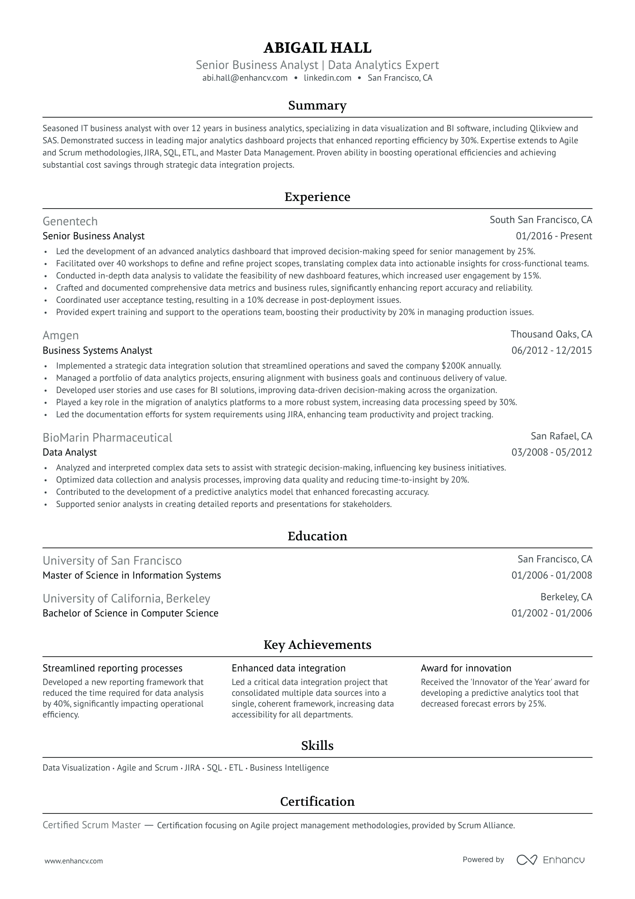

**Code:**

<!DOCTYPE html>

<html lang="en">

<head>

    <meta charset="UTF-8">

    <meta name="viewport" content="width=\, initial-scale=1.0">

    <title>Sneh Naik - Resume</title>

    <!-- <link rel="stylesheet" href="resume.css"> -->

    <!-- <script src="https://cdn.tailwindcss.com"></script> -->

    <style>

        * {

            padding: 0%;

            margin: 0%;

            box-sizing: border-box;

        }

        .content {

            display: flex;

            flex-direction: column;

            /* align-items: center; */

            width: 100%;

            padding-bottom: 20px;

        }

        .subtitle {

            font-size: 20px;

            font-weight: bold;

            color: rgb(112, 112, 112);

        }

        hr {

            width: 100%;

        }

        h3 {

            text-align: center;

        }

    </style>

</head>

<body>

    <div class="main"

        style="font-size: 18px; display: flex; flex-direction: column; height: 100vh; align-items: center; background-color: white; padding: 40px;">

        <div class="header content" style="font-size: 21px;">

            <h1  style="text-align: center;"  style="font-size: 25px;">Sneh Naik</h1>

            <h3 class="subtitle" style="text-align: center;"  style="font-size: 21px;">Web Developer</h3>

            <h5 class="subtitle" style="text-align: center;"  style="font-size: 17px;">naiksneh6@gmail.com | LinkedIn | Ahmedabad</h5>

        </div>

        <div class="summary content">

            <h3>Summary</h3>

            <hr>

            <div class="conttext">

                <strong class="subtitle">Full-Stack Developer</strong> <br>

                Proficient in HTML, CSS, JavaScript, ReactJS, ExpressJS, MongoDB, and MySQL, with a strong foundation in

                Java and data visualization using Python. Experienced in building both frontend and backend projects

                with a focus on efficiency and collaboration. Quick to adapt, committed to timely task completion, and

                passionate about continuous learning

            </div>

        </div>

        <div class="content experience">

            <h3>Experience</h3>

            <hr>

            <div class="subtitle">

                Gateway Corp

            </div>

            <div class="">Web Developer Intern</div>

            <div class="">Developed two full-stack web applications, a book management system and a cash flow tracker,

                using the MERN stack to deliver dynamic and responsive user experiences.</div>

        </div>

        <div class="content">

            <h3>Education</h3>

            <hr>

            <div class="edu">

                <div class="insti subtitle" style="display: flex; justify-content: space-between;"><div>Pandit         Deendayal Energy University</div>

                <div>Gandhinagar, Gujarat</div>

                </div>

                <div class="scores" style="display: flex; justify-content: space-between;"><div>Information and Communication Technology</div><div class="subtitle">2022-2026</div></div>

            </div>

        </div>

        <div class="skills content">

            <h3>Skills</h3>

            <hr>

            <ul>

                <li>HTML, CSS , REACT, EXPRESS, MONGODB</li>

                <li>PYTHON, JAVA</li>

                <li>VSCODE, ANACONDA</li>

            </ul>

        </div>

        <div class="content">

            <h3>Projects</h3>

            <hr>

            <ul>

                <li>

                    <div class="proj">

                        <div class="subtitle">Books Management app</div>

                        <div class="projdetails">

                            Developed a full-stack MERN web application where people can upload and share their books to

                            multiple user achieved with the help of Multer and Cloudinary for book cover image and file

                            upload. Implemented user authentication using JWT dynamic search, sorting, and RESTful APIs

                            for backend operations. Designed MongoDB database schema for efficient data storage.

                            Tech Stack: ReactJS, Node.js, ExpressJS, MongoDB, Cloudinary

                        </div>

                    </div>

                </li>

                <li>

                    <div class="proj">

                        <div class="subtitle">Cash Flow Manager</div>

                        <div class="projdetails">Created a MERN-based platform for tracking income, expenses, and

                            savings. Implemented user

                            authentication using JWT for security and privacy. Designed a complex MongoDB schema to

                            handle user transactions and categorize transactions based on type such as inflow or outflow

                            and

                            further categorized based on sub categories created by the user.

                            Tech Stack: ReactJS, Node.js, ExpressJS, MongoDB</div>

                    </div>

                </li>

            </ul>

        </div>

    </div>

</body>

</html>

**Output:**

